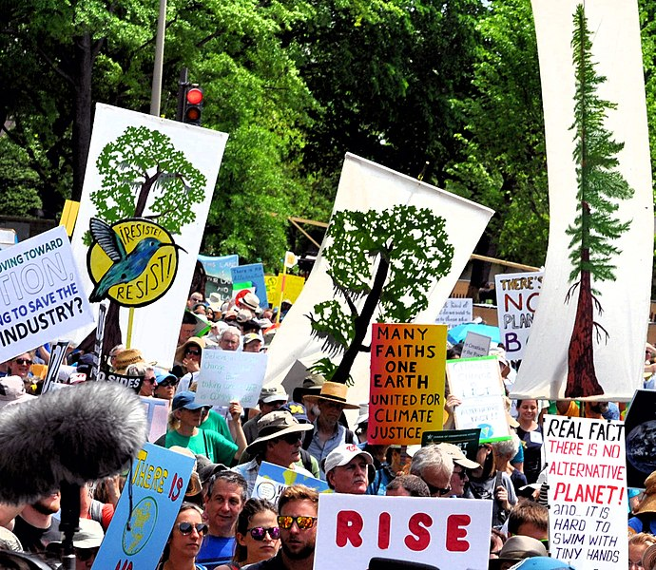

All faiths [Many Faiths One Planet - Climate Outreach](https://climateoutreach.org/18637756484_393baf5020_h/?unapproved=21819&moderation-hash=f3af019acef9296e4800a749c91e6e12#comment-21819)

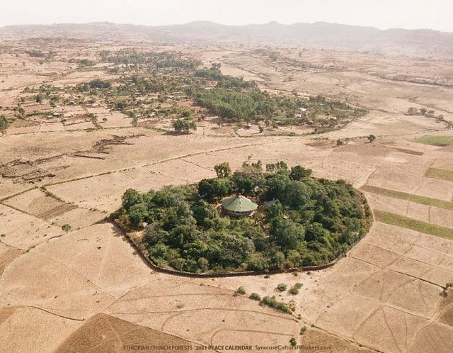

Christianity [Biodiversity thrives in Ethiopia’s church forests (nature.com)](https://www.nature.com/immersive/d41586-019-00275-x/index.html?WT.ec_id=NATURE-20190131&utm_source=nature_etoc&utm_medium=email&utm_campaign=20190131&sap-outbound-id=815D4C9DD975FCED02DEA72F56E25FB2F0F9944D)

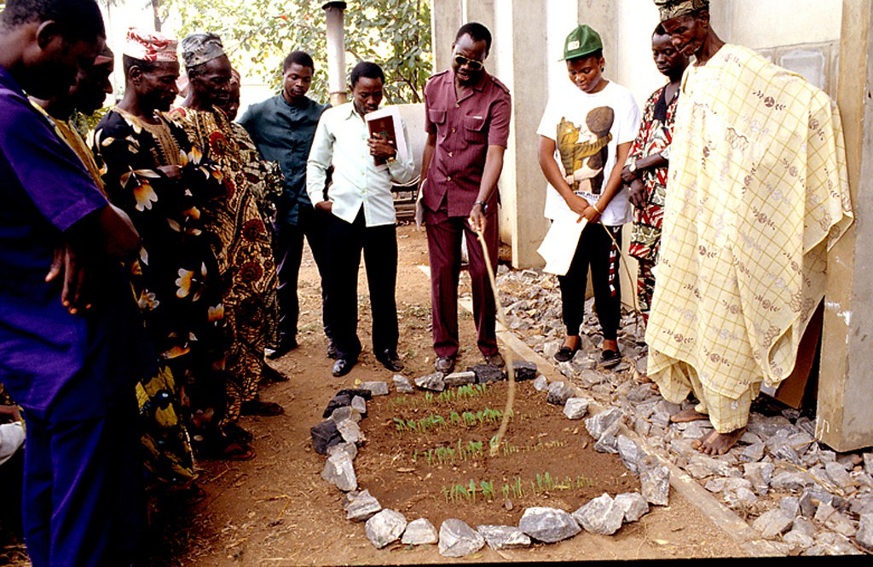

Christian farmers learning about sustainable farming methods.

Christianity [GREEN ANGLICANS MOVEMENT LAUNCHES IN RWANDA – Green Anglicans](https://www.greenanglicans.org/green-anglicans-movement-launches-in-rwanda/)

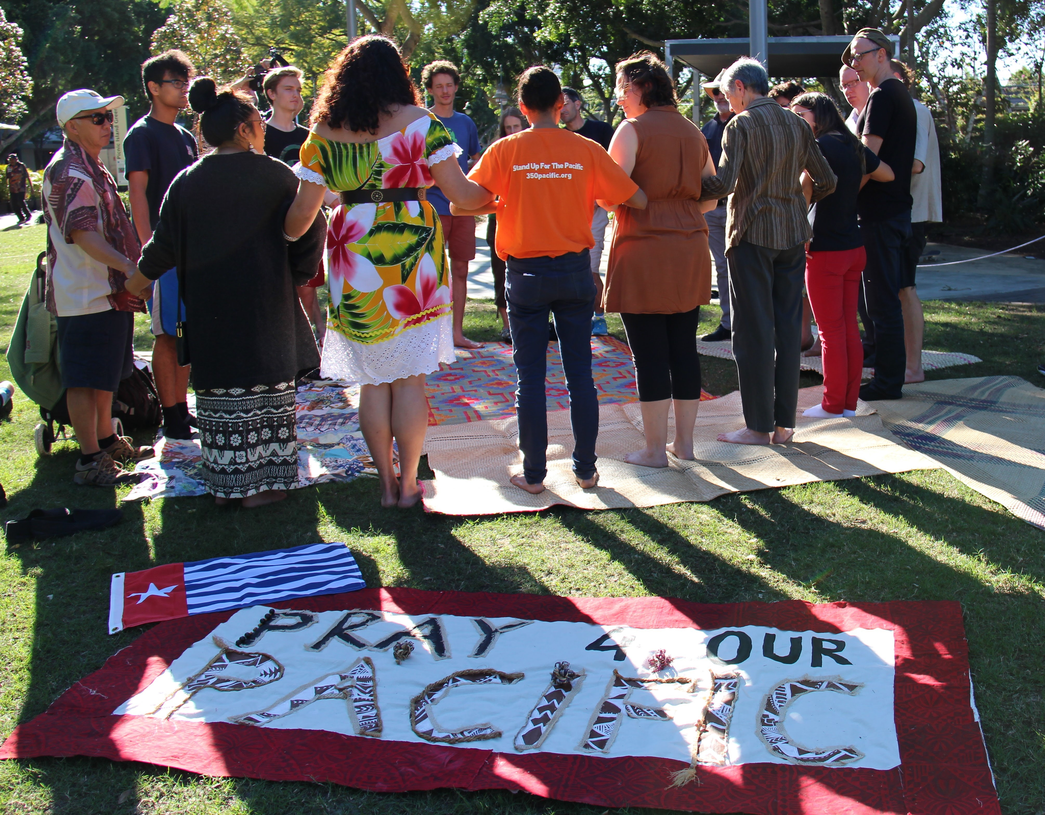

## "In the Pacific, we are one big family. [#PrayForOurPacific](https://www.flickr.com/photos/tags/PrayForOurPacific) is a way to empower ourselves. It's an opportunity to acknowledge one another with thanks and to remember those on the front lines of climate change. There is power in prayer. Its time to stand as one." - Lisa Jameson, 350 Pacific Brisbane Coordinator.

## Massive thanks to folks from Friends of the Earth, University of the South Pacific, Rize for West Papua, Fossil Free UQ, Brisbane Solidarity Group and 350 Australia as well as members of the Brisbane Community for taking part in the prayer circle held on Sunday.

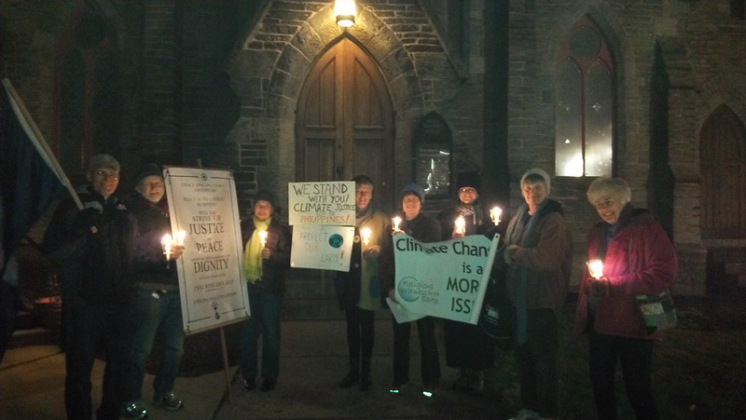Praying and singing for climate justice in front of Grace Episcopal Church, Amherst, MA.

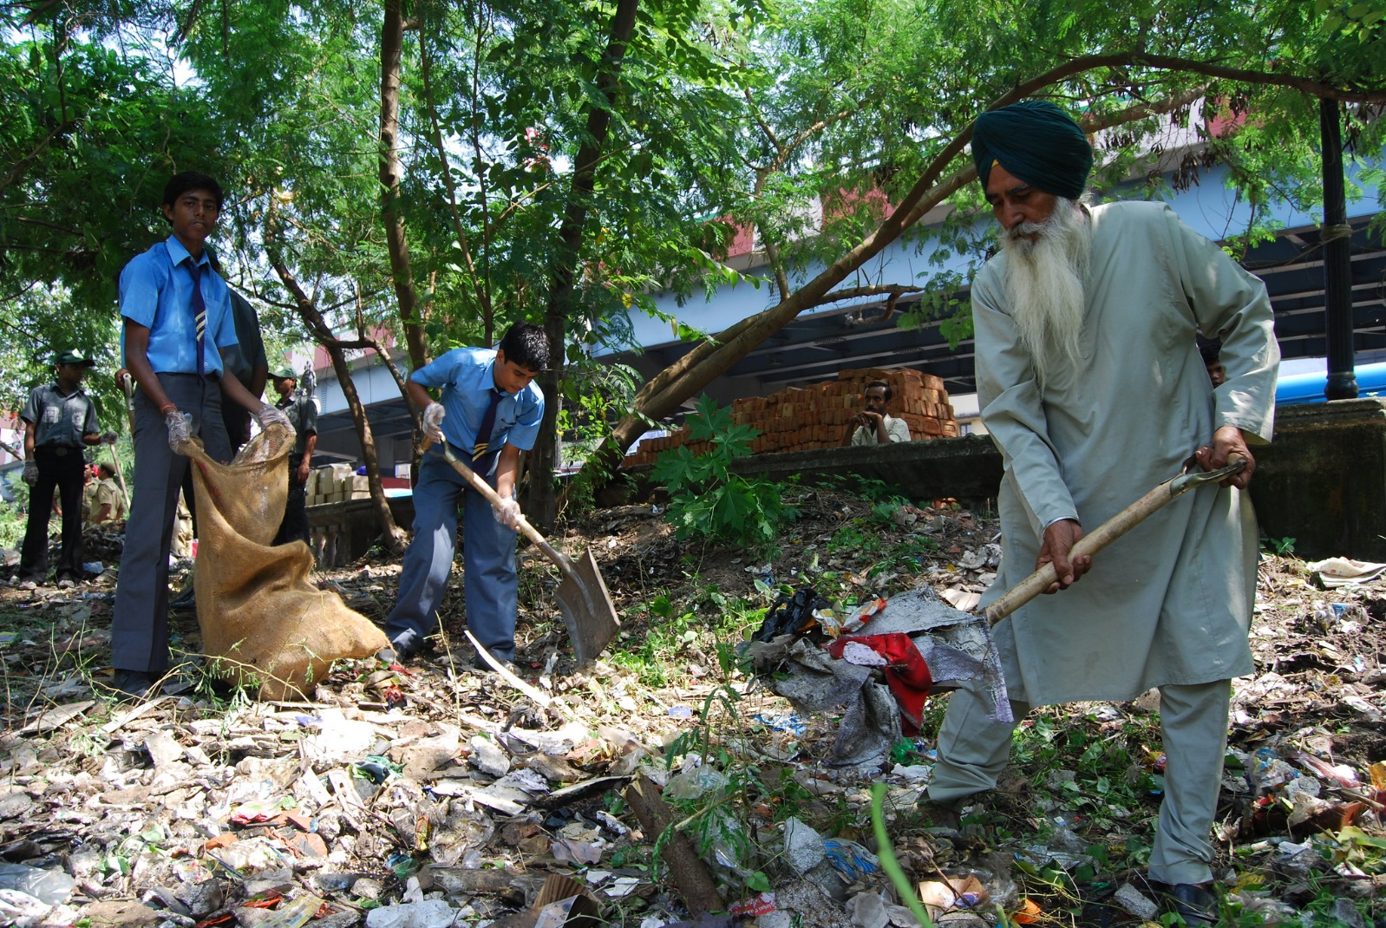

Sikh [EcoSikh](https://ecosikh.org/)

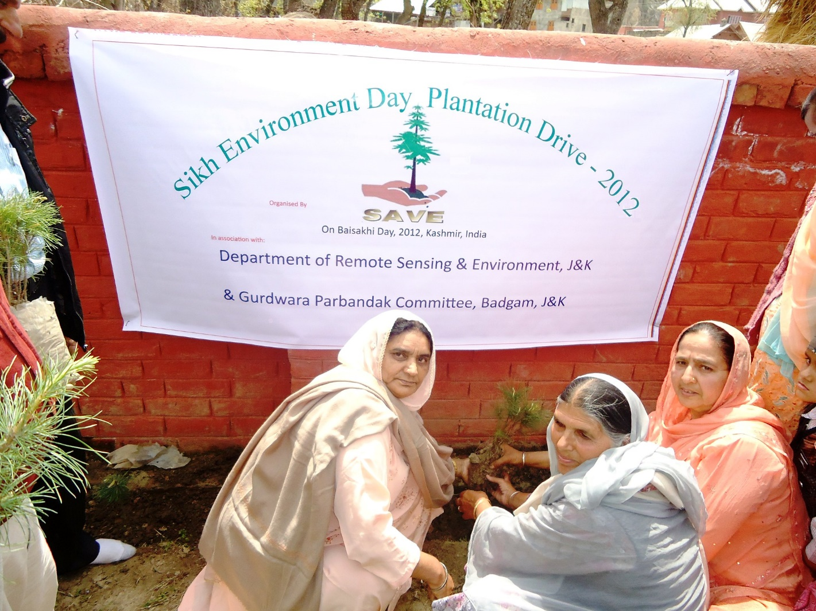

Sikh [EcoSikh](https://ecosikh.org/)

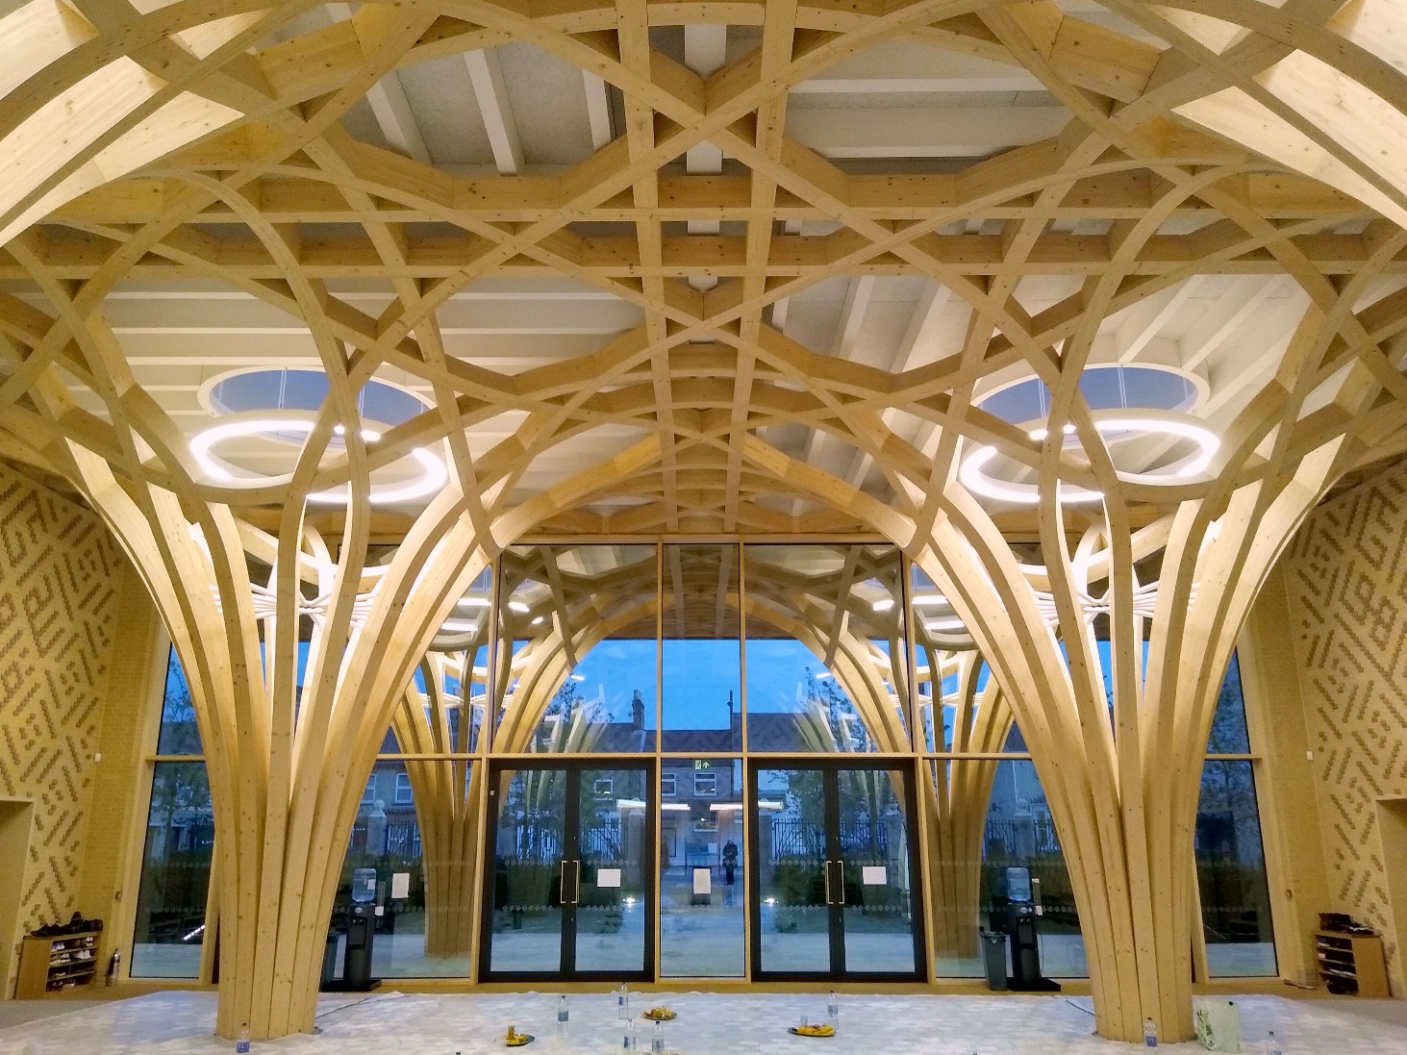

Islam [Green: Cambridge Eco-Friendly Mosque (hadhramouts.blogspot.com)](https://hadhramouts.blogspot.com/2011/01/green-cambridge-eco-friendly-mosque.html)

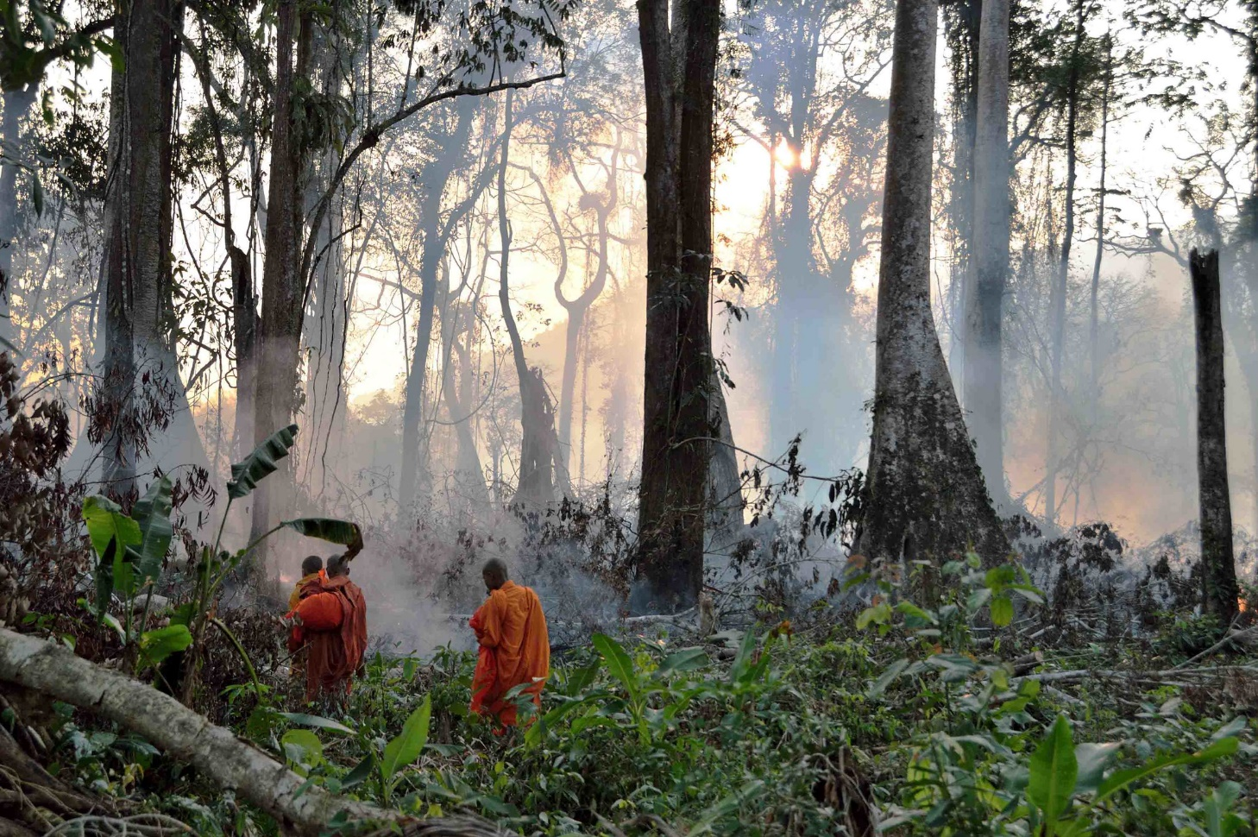

Buddhist monks walk through tropical forest set on fire to clear it for a plantation. They are ordaining trees in the area of Ta Tay Ler to try and stop forest encroachment.

[Buddhists ordain trees as monks to save forests (faithplans.org)](https://www.faithplans.org/post/buddhists-ordain-trees-as-monks-to-save-forests)

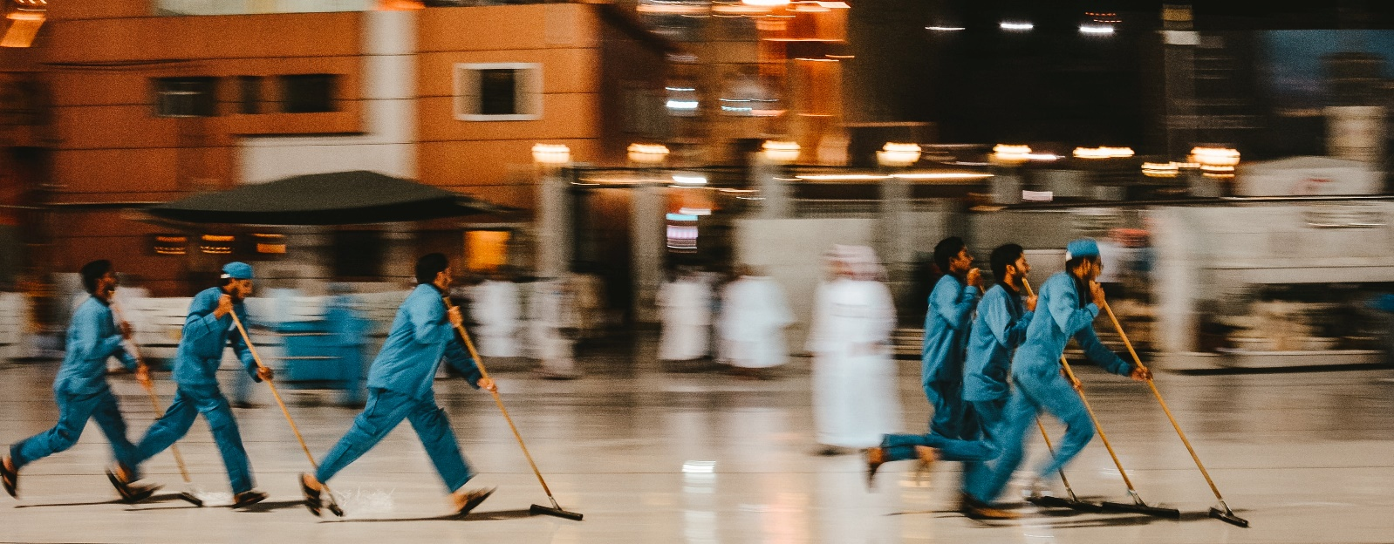

Muslim [Green Hajj | Being the guardian of the earth](https://greenhajj.org/) Unsplash



Jewish [West London Synagogue - EcoSynagogue](https://ecosynagogue.org/west-london-synagogue/)



Tu B’shvat

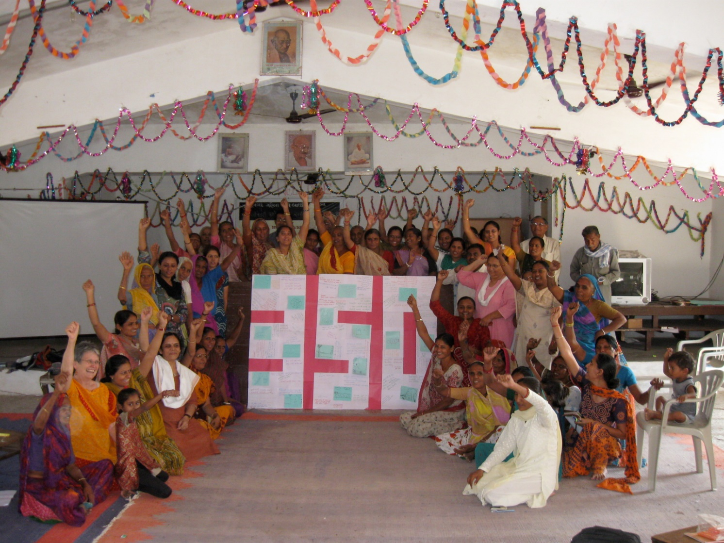

Koda Village near Ahmedabad, India

The women and men in this photo are salt farmers and agricultural farmers in the desert regions surrounding the Little Rann of Kutch in the Indian state of Gujarat. They are members of the Indian women's empowerment organization, SEWA, Self Employed Women's Association, which boasts 700,000 women members. The people in this photo are extremely poor and totally dependent on the monsoon rainfall for their livelihoods. They have observed the changes in monsoon patterns, the increase in frequency of droughts, and the changes in the crops they can harvest successfully.

Each woman wrote what she would promise to do about climate change on this large poster. Here are a few of the quotes, loosely translated from Gujarati:

"I will use a bullock when farming, and I will plant 50 trees with help of other women. I will use water cautiously and reduce wasting water. I will not use any electricity for two hours each day."

"I and each family member will plant a tree and take care of it."

"I will use as much solar power as possible and tell my village how to use bio-gas."

"I will start harvesting roof top rainwater."

"I will celebrate my children's birthdays, not with cake, but by planting a tree."

Hindu [Women as climate action ambassadors in coastal districts of India’s Odisha State (unep.org)](https://www.unep.org/news-and-stories/story/women-climate-action-ambassadors-coastal-districts-indias-odisha-state)

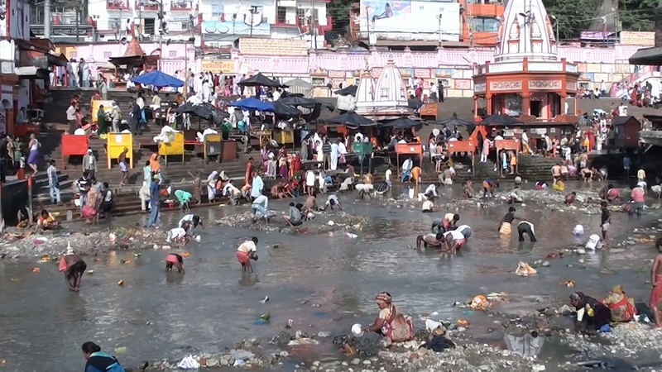

This is a picture of the dry river bed of the Ganga Canal. The Ganga Canal in Haridwar is dried every year on Dussehra to clean the river bed and the waters are restored on Diwali.